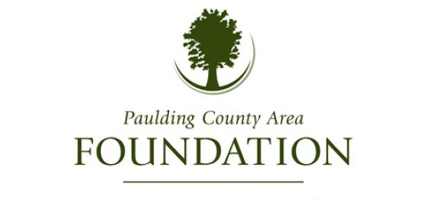
The Paulding County Area Foundation exists to enrich the quality of life for our community, and one faucet of enrichment is through scholarships. The Paulding County Area Foundation annual scholarship application period for the 2023-2024 school year opened on January 1, 2024 and will close April 1st, 2024. Please note, late applications will not be accepted or taken into consideration. All applications must be submitted online. Please visit the Paulding County Area Foundation website at: www.pauldingcountyareafoundation.com and click on “Scholarships” to view all scholarship opportunities. Certain scholarships are only available for specified school districts, so we highly encourage each applicant to find their school’s page on the Foundation’s website to ensure they are only applying for scholarships applicable to them.
These scholarships would not be possible without the support of generous donors/families. We know that these opportunities serve to not only enrich these student’s educational careers but also the community of which they are a part of. The Paulding County Area Foundation wishes the Class of 2024 the best of luck in their future educational endeavors.

