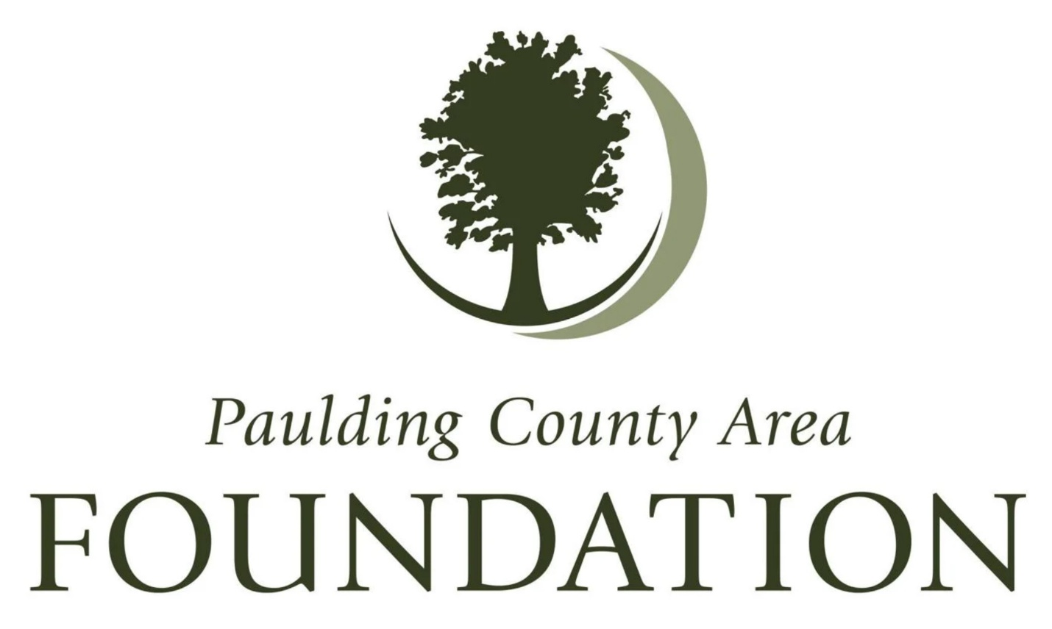Paulding County Area Foundation Awards Over $90,000 in Community Grants to Support Local Initiatives
Paulding County, OH – The Paulding County Area Foundation is proud to announce the distribution of over $90,000 in community grants to support local organizations dedicated to improving the quality of life for residents throughout the county. These grants will fund essential projects and services that align with the Foundation’s mission to enrich the quality of life in our community.
The 2025 Community Grants will benefit the following organizations and initiatives:
- Hopes Harbor – Funding for hotel stays to support families of children receiving medical treatment, ensuring they can remain close to their loved ones during critical times.
- Payne Fire Association – Grant for a new extrication system to enhance emergency response and rescue capabilities in the community.
- Paulding County Parks District – Funding for electricity installation at the Rochester Park Pavilion, improving accessibility and usability for community events.
- Children’s Hunger Alliance – Support for shelf-ready food for students in Paulding County, addressing childhood hunger and ensuring access to nutritious meals.
- United Way of Paulding County – Grant funding for the Dolly Parton Imagination Library, a program that promotes early literacy by providing free books to children.
- Grover Hill Firefighters – Funding for iPads to improve medical record management for EMS patients, enhancing the efficiency of emergency medical care.
- Paulding County Parks District – Additional support for the expansion and maintenance of the Paulding County Parks Trail System, promoting outdoor recreation and wellness.
- Friends of the Grover Hill Library – Assistance for building repairs to preserve and maintain a vital community resource.
- Paulding County Economic Development – Funding to support housing development projects, addressing local housing needs and economic growth.
These initiatives directly align with the Paulding County Area Foundation’s mission by supporting essential community services, improving public safety, expanding educational opportunities, enhancing public spaces, and strengthening local infrastructure. By investing in these projects, the Foundation continues to make a lasting impact on the well-being and future of Paulding County.
“We are honored to support these outstanding organizations and the work they do to strengthen our community,” said Lisa McClure, Executive Director of the Paulding County Area Foundation. “Each of these projects plays a vital role in enriching the lives of our residents, and we are proud to be part of these efforts.”
For more information about the Paulding County Area Foundation and its grant programs, please visit www.pauldingcountyareafoundation.com or email us at: pauldingfoundation@gmail.com. If you are interested in donating, those can be mailed to 101 E. Perry St., Paulding, OH 45879

